Networking
Hardware requirements.
1) ethernet card, NIC(network interface card), LAN card.
2)cabals
3)Network device
logical Terms:
IP address
mac address
source and destination address
IPv4(internet protocol) - 32 bit
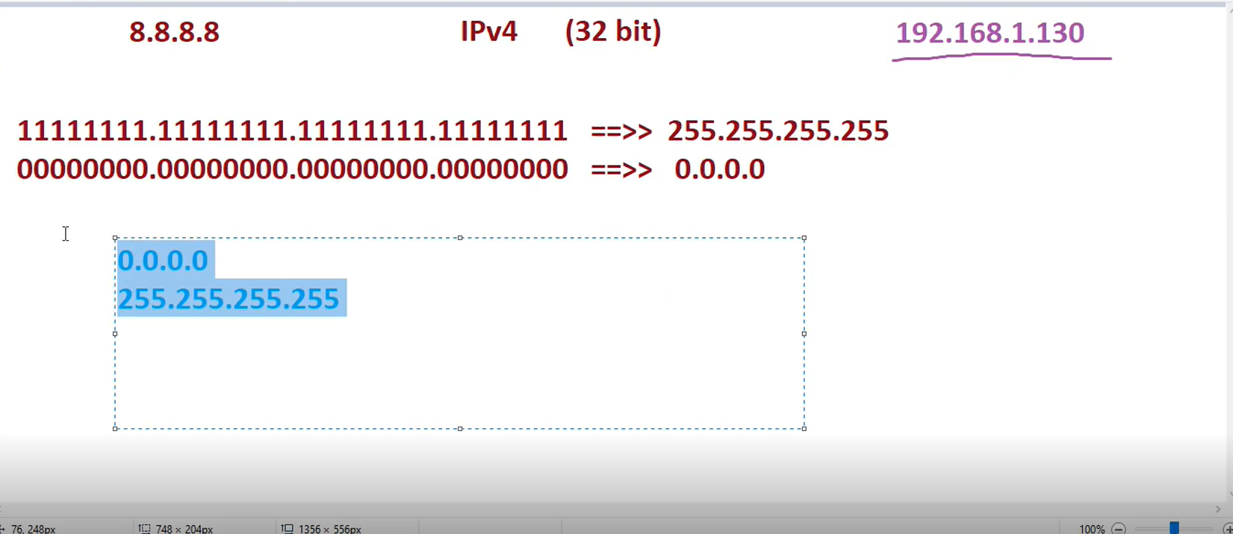
IP class
A class- 0-126
B class 128-191
C class 192-223
D class 224-239
E class 240-255
127 ip is reserved for loopback or localhost.
Class D and class E is for special purpose or research purpose
Network address: is the first IP address of any IP range.
Broadcast address: this is the last IP address of any IP range.
this class have their networks and host addresses
class A - N.H.H.H
class B - N.N.H.H
class C - N.N.N.H
Suppose my IP is 192.168.1.60 and I want to calculate my network address and broadcast address
this is from class C contain 3 Network beat and 1 host
then simple 192.168.1.0 this is network address
and just convert to 0-255 make broadcast address = 192.168.1.255
and remain are IP address
192.168.1.1 ---- 192.168.1.254
the number of usable IP address in class c in 1 network are total 256-2 =254 IP address.
EX-2) 172.20.1.215
class B N.N.H.H
Network address 172.20.0.0
broadcast address 172.20.255.255
and remain are usable IP address in single network
172.20.0.1 ---- 172.20.0.255 ---172.20.1.0---172.20.1.255---172.20.2.0----172.20.2.255
and last IP is 172.20.255.254 cause this 172.20.255.255 is broadcast
IP addresses= 256*256-2=65536-2=65534
Ex-3) 56.104.25.99
Class A N.H.H.H
network Address 56.0.0.0
broadcast address 56.255.255.255
and remain are usable IP address in single network
59.0.0.1-----59.0.0.255---59.0.1.0---59.0.1.255---59.0.2.0---59.0.2.255 and more
so last IP is 59.255.255.254
IP addresses = 256*256*256-2=16777214
subnetting:
suppose we have 5 different departments IT,HR,Finance and other they all in same network that is 192.168.1.0 so they can communicate with each other but we don’t want it in this network there are total 254 IP addresses usable and we need to give all departments 25 each and they don’t isolated from each other so we use subnetting for this.
or
subnet = sub network, means devide the network into multiple logical sub network.
subnet mask= A subnet mask is a 32-bit number that divides an IP address into a network and host portion
subnet class A = 255.0.0.0
Class B = 255.255.0.0
class C = 255.255.255.0
if you give plain IP so we can check from which class by noticing their first octet
and it IP have subnet then this IP is belongs to their class
like 192.168.1.45 this is class C, but we apply the subnet on this
like 192.168.1.45/255.255.0.0 then this IP is from class B
like 192.168.1.45/255.0.0.0 then this IP is from class A
another way to wright subnet mask (CIDR)
Class A subnet =255.0.0.0 it contain 8 bit on so /8
class B subnet = 255.255.0.0 it contain 16 bit on so /16
class C subnet = 255.255.255.0 it contain 24 bit on so /24
192.168.1.45/8 class A
192.168.1.45/16 class B
192.168.1.45/24 class C
video 2 mobile private IP
DHCP public IP laptop private IP
ISP ---------router PC private IP
(internet service provider)
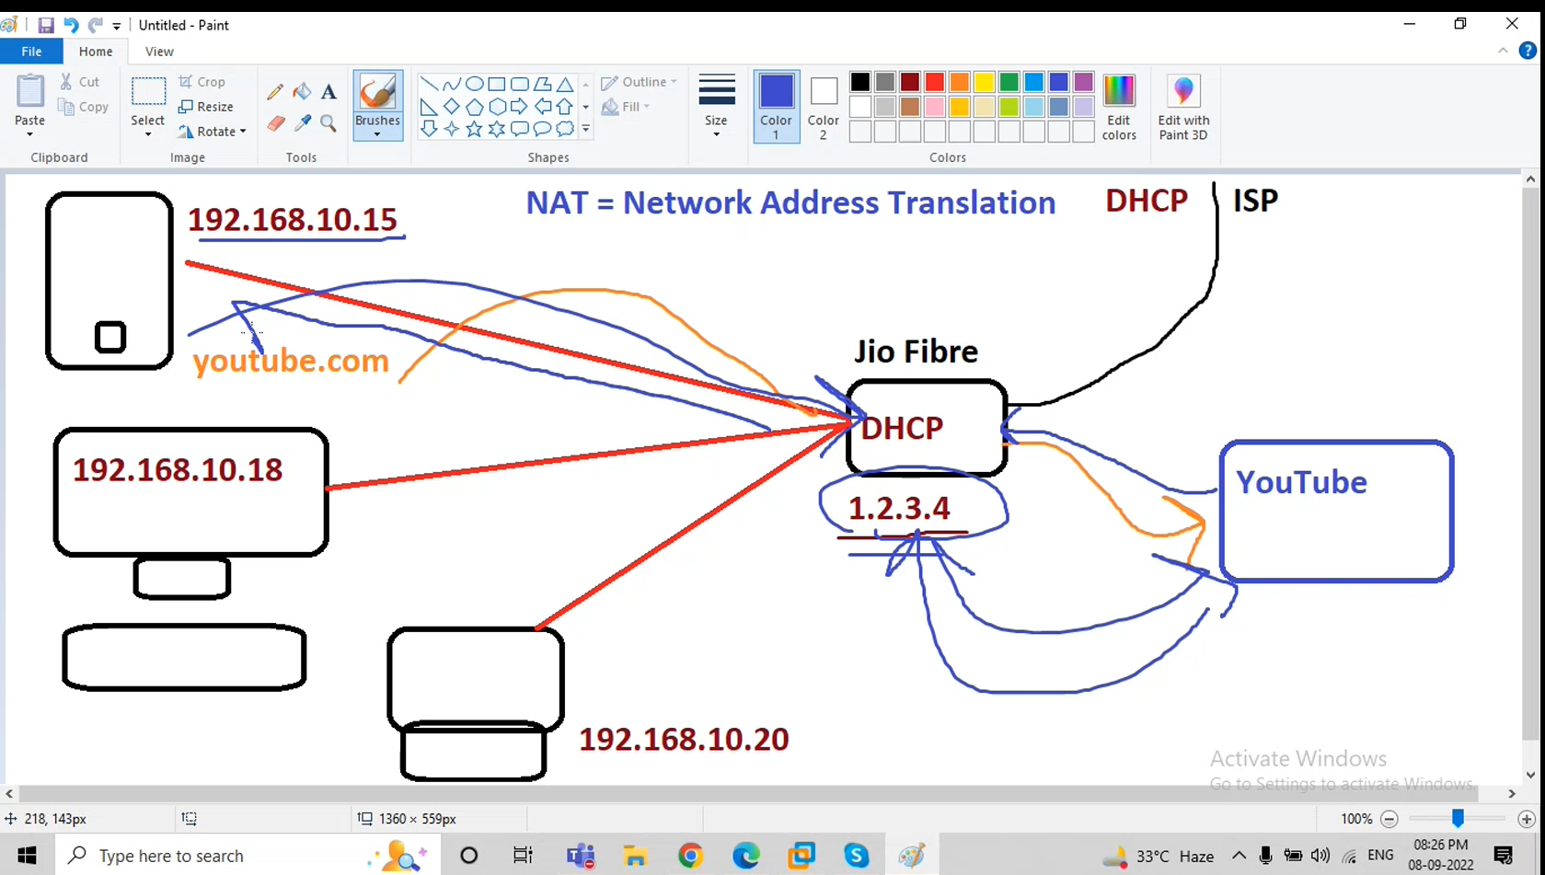
when server makes request youtube.com then it first goes to the router then source address of server is changed means source IP from private to public using the NAT(Network Address Translation). The youtube server get our public IP of router not an private of our server then again from reverting back request it reach to router then it change destination address from router public IP to server private IP and then we get the output of youtube.
Feature | Private IP Address | Public IP Address
Definition | IP address used within a private network (LAN) | IP address used to identify devices on the Internet
Accessibility | Only accessible within internal networks | Accessible globally over the Internet
Example Ranges | - 10.0.0.0 – 10.255.255.255  - 172.16.0.0 – 172.31.255.255  - 192.168.0.0 – 192.168.255.255 | Any IP not in private range (e.g. 8.8.8.8, 1.1.1.1)
Assigned By | Chosen by network admin or DHCP | Assigned by ISP or IANA
Used For | Internal communication (e.g., home, office LAN) | Communication over the internet
ISP provides and internet to router then router get an public IP and this given from DHCP server from ISP. Then all devices which is connected to router get an private IP address.
and is there any request from mobile to internet it goes like mobile routerinternet server and the IP get this server is not mobile private IP it gets router Public IP.
public IP ==Real IP
Private IP== virtual IP
server-client model
server = who serve the services
client = who use this services
Total ports in system = 65535
socket=ip:port
client webserver
when client send request to server it get IP only but application not works on it ,the application works on ip:ports
dig: (domain information grouper)
it is same like nslookup but it is advanced.
Feature | dig | nslookup
Output format | Structured, detailed | Simpler, less structured
Scripting usage | Easier (with +short, etc.) | Harder to parse in scripts
Standards | Modern, follows DNS RFCs closely | Slightly outdated behavior
Popularity | Preferred by professionals | Still available but less favored
Development | Actively used in diagnostics | Considered deprecated by some

Feature | IPv4 | IPv6
Full Name | Internet Protocol version 4 | Internet Protocol version 6
Address Size | 32 bits | 128 bits
Address Format | Decimal, dotted format | Hexadecimal, colon-separated
Example Address | 192.168.0.1 | 2001:0db8:85a3:0000:0000:8a2e:0370:7334
Configuration | Manual or via DHCP | Auto-config or DHCPv6
network devices:
Hub
Switch
Router
1.Hub
in this Hub case: 4 host connected to Hub when host 1 want to connect to host3 then host 1 make request to host 3 then first it goes to Hub then Hub broadcast all host who is host3 (IP) then Host3 say I am then Host1 connect to host3.
but one issue in Hub if host2 says I am host3 then Hub directly connect to host2 without any checking
host1 HUB host2
2.switch
same like Hub the switch firstly broadcast the each host and one thing he captured the mac of each host and stored in mac table and in this table contain data like IP=Mac address.
and next time any host perform request it not broadcast this time he did unicast directly connect to right host based on this mac table.
3.Router
communication between different networks.
and it provides route to our network.
TCP/IP model:
Contain 4 layers
1. Application
2. transport layer (TCP/UDP) TCP=transmission control protocol UDP=user datagram protocol
3. network layer
4. physical or datalink layer
Feature | TCP (Transmission Control Protocol) | UDP (User Datagram Protocol)
Connection | Connection-oriented (handshake before data) | Connectionless (no handshake)
Reliability | Reliable – ensures data is delivered in order | Not reliable – no guarantee of delivery
Speed | Slower (due to checks and acknowledgments) | Faster (no checks or confirmation)
Use Case | File transfer, web browsing, emails (when data must arrive correctly) | Streaming, gaming, voice calls (speed > accuracy)
Error Checking | Yes, with acknowledgment and retransmission | Minimal error checking
Examples (Ports) | HTTP (80), HTTPS (443), FTP (21), SSH (22) | DNS (53), DHCP (67/68), VoIP (5060)
video 3
there are types of ethernet card
1)ethN == eth1, eth2, eth3
2)enoN == en01, eno2, eno3 (ethernet on)
3)ensN == ens1, ens2, ens3
how to work ping command
when we did ping 192.168.1.54
then my host send echo request(ICMP packets) to this ip server and revert back to the host then connectivity with this host and IP is happened.
when we did ping google.com
it first goes to /etc/hosts if it contain domain with IP address then it revert back to them if not it goes request to /etc/resolve.cong where we mentioned the dns server like 8.8.8.8 or 8.8.4.4 then it goes to the internet.
find IP from domain
use nslookup command
find which port on running
netstat -tulnp
ss -tulnp
connection= collection of setting.
nmcli device status
nmcli connection show
setting of manual IP setup through UI
nmtui
hostnamectl

